LAB ASSIGNMENT V : HUERISTIC EVALUATION
SYSTEM EVALUATED : Bharat Matrimony Redesign
Groups members NAME :
Nikhil Karmare
Sahil Pawar
Arhaan Mulani
Akshwaj Rao

PART I : HUERISTIC EVALUATION BASED ON NIELSEN'S 10 GENERAL PRINCIPLES FOR INTERACTION DESIGN. (0 is lowest and 10 is highest)
S.No. | Heuristic Evaluation Parameter | Mention Violation if any | Severity  0–10 | Ways to improve
1 | User Control | Default international auto-renewal and irreversible profile deletion reduce user control. Deactivation and deletion are not clearly distinguished. | 5/10 | Make auto-renewal explicit opt-in; separate Deactivate/Delete; add confirmation and a recovery grace period.
2 | Human Limitations | Five membership tiers, three durations and three add-ons create high decision load. Dense repeated footer links add clutter. | 5/10 | Highlight a recommended plan, simplify comparisons, consolidate repeated links and progressively reveal advanced options.
3 | Accommodation | The platform supports parent-created profiles and community-based search, fitting the documented parent persona, but the relative-created profile flow is not clearly explained. | 7/10 | Explain how parent/relative-created profiles are labelled, verified and later approved; simplify community filters for less tech-comfortable users.
4 | Linguistic Clarity | Prime vs Regular, subcaste/gothra usage and free-vs-paid capabilities are not sufficiently explained at the point of decision. | 6/10 | Add plain-language explanations beside unfamiliar terms and show free-vs-paid capabilities before users hit a restriction.
5 | Aesthetic Integrity | Core widgets and colour palette are consistent, but multiple promotional banners and repeated footer groups reduce visual focus. | 6/10 | Reduce competing promotional blocks and consolidate footer content while preserving important trust information.
6 | Simplicity | Many search modes, membership tiers, durations and add-ons increase complexity for first-time users. | 5/10 | Provide one primary search path, progressively reveal Advanced Search and simplify membership selection.
7 | Predictability | Core navigation is understandable, but payment restrictions can be discovered only after a user attempts a gated action; validation status is not visible enough. | 6/10 | Explain restrictions before actions, add breadcrumbs and show clear validation/progress states.
8 | Accuracy | The analysis found conflicting years-of-operation figures and apparent duplicate/mis-grouped retail locator entries, reducing trust in information accuracy. | 4/10 | Use a single source of truth for brand statistics and audit the retail-locator database.
9 | Technical Clarity | Important rules such as validation timing, password limitations and paid-feature restrictions are often deferred to the FAQ instead of explained in context. | 6/10 | Surface account and system rules where relevant; use contextual help and visible status indicators.
10 | Fulfillment | Strong search, trust signals, success stories and community filters support the matchmaking goal, but payment complexity and irreversible actions reduce satisfaction. | 6/10 | Create a smoother registration-to-shortlist-to-contact flow with clear expectations about free access, paid features and account closure.
11 | Consistency | Header, login widget and colour palette are consistent, but 'years in operation' figures conflict across pages and some information structures are inconsistent. | 5/10 | Centralize trust statistics and standardize labels, navigation patterns and membership information.
12 | User Support | FAQ and 24x7 helpline provide strong support, but important explanations are often available only after the user searches for help. | 7/10 | Add contextual help near complex fields, explain Prime/Regular and subcaste/gothra inline, and guide payment/validation.
13 | Precision | Search/discoverability is strong with Regular, Advanced, Soulmate, Keyword, ID and Prime/Regular options, but advanced fields can be opaque. | 8/10 | Keep rich filters while adding filter descriptions, active-filter summaries and clear explanations of community fields.
14 | Forgiveness | Profile deletion is irreversible and photo/horoscope protection passwords have limited recovery options. | 3/10 | Add reversible deactivation, a deletion grace period, destructive-action warnings and a supervised recovery route.
15 | Responsiveness | Email/SMS notifications are documented, but registration lacks visible progress/confirmation and photo/horoscope validation lacks an on-page pending state. | 6/10 | Show loading, success, error and pending states, expected validation time and clear submission confirmation.
 | Total Score |  | 85/150

Screenshots :
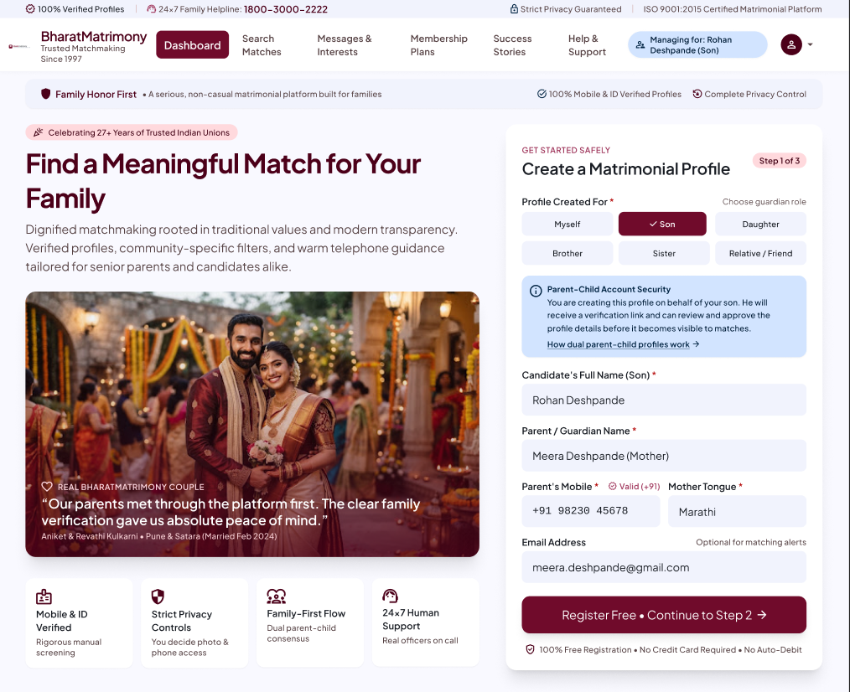
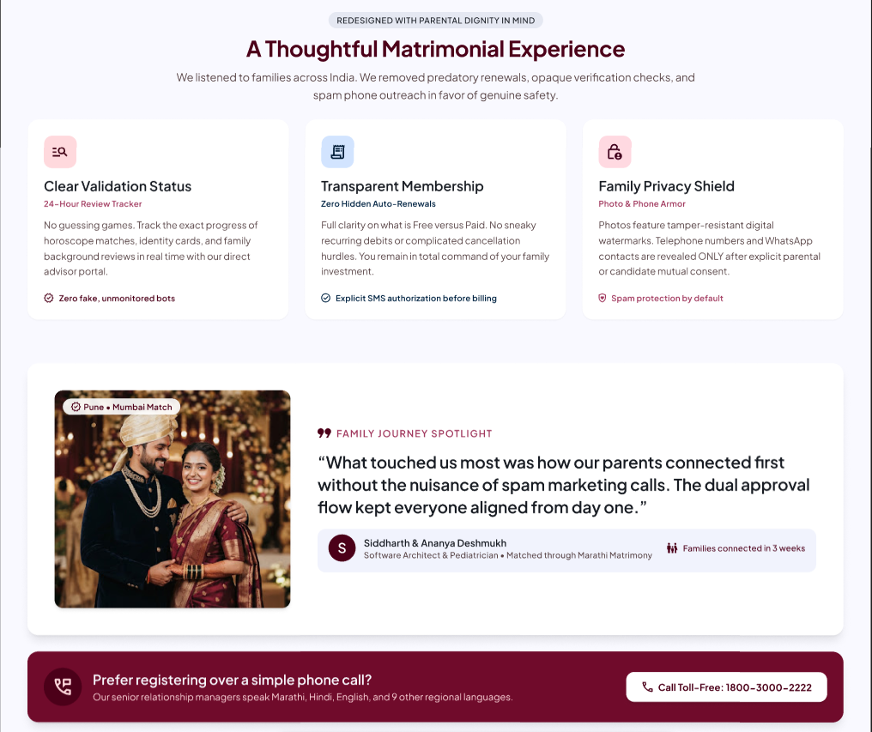
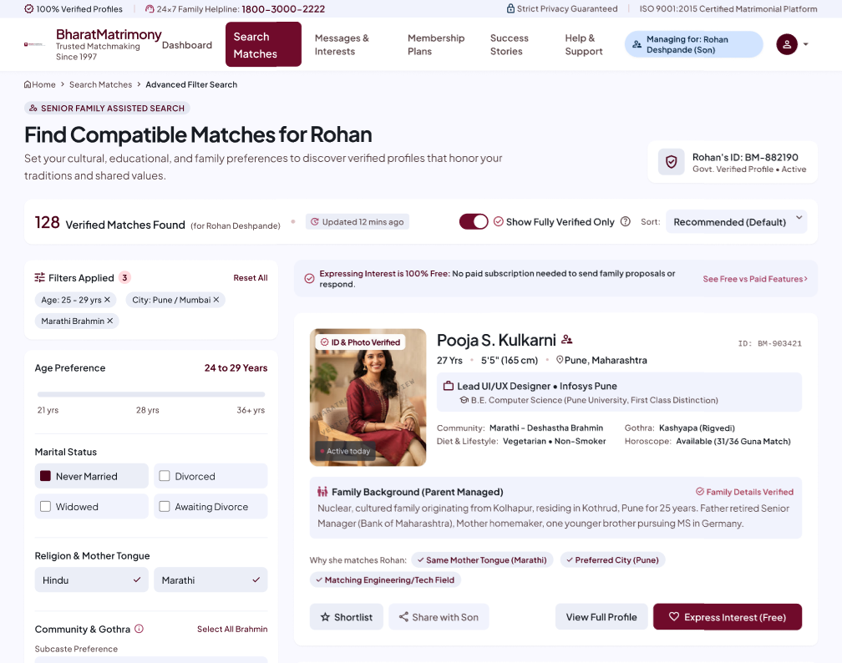
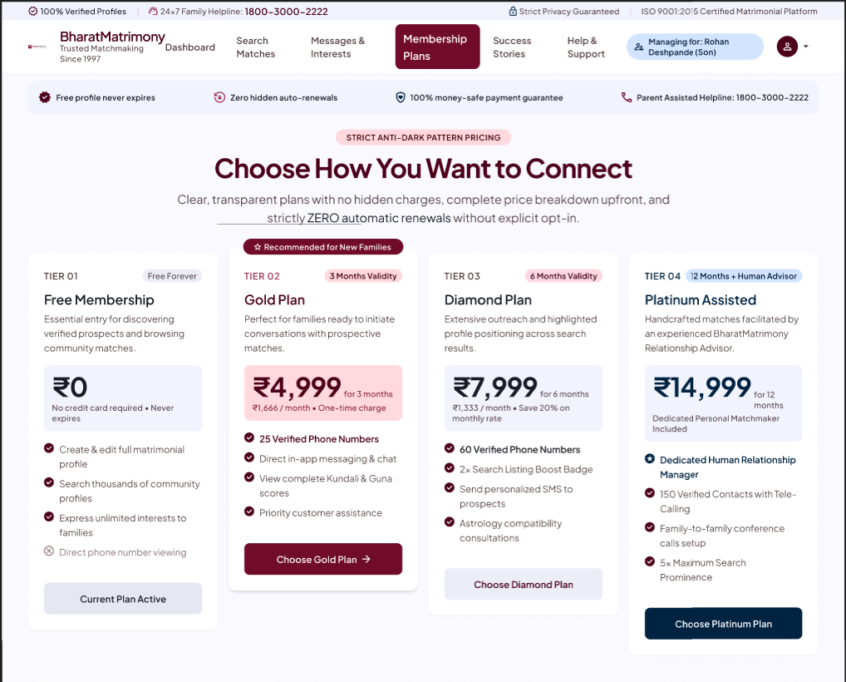
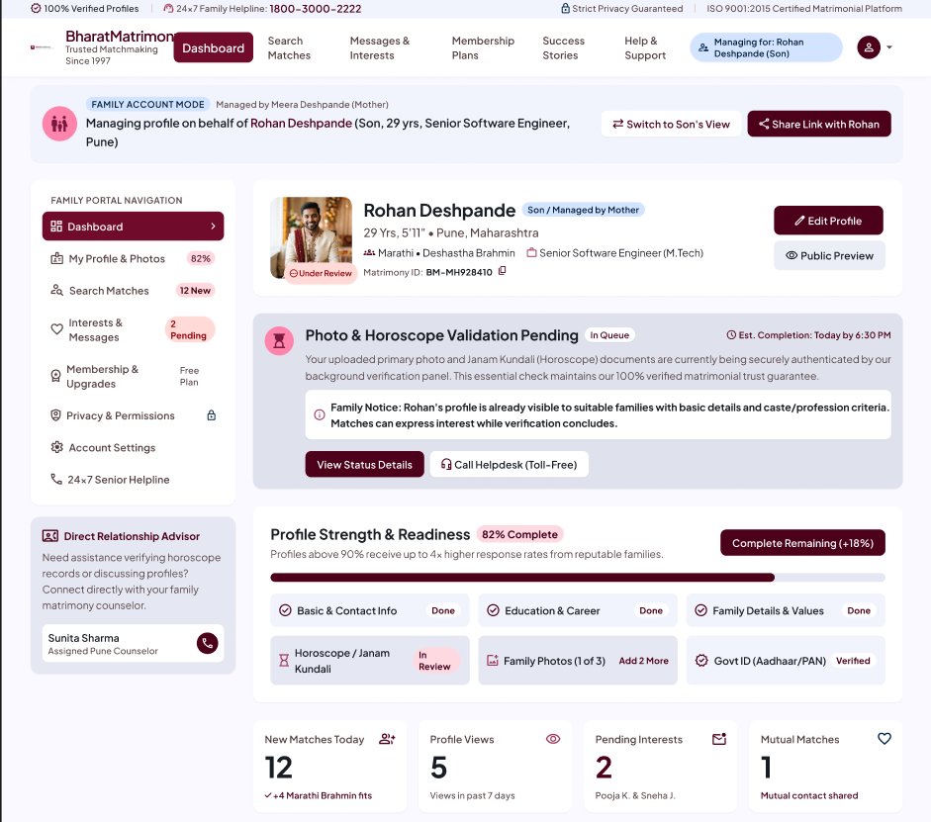

PART II : List out any other points that you may have missed out . (Other than Nielsen’s Principles)

S.NO | OBSERVATIONS | COMMENTS
1 | Profile creation for relatives | The registration flow supports Son/Daughter/Relative profiles, but does not clearly explain how the candidate is represented, verified or involved later.
2 | Validation status | Photo and horoscope validation may take 1–24 hours according to the project analysis, but no clear pending/approved/rejected status is shown on the profile.
3 | Free vs paid transparency | Phone numbers, chat and personalised messages are paid features, but the distinction is documented mainly in the FAQ rather than surfaced at the decision point.
4 | Membership decision load | Five tiers, three durations and three add-ons create high first-time decision complexity. A recommended plan would reduce the load.
5 | Privacy explanation | Advanced Search includes subcaste and gothra fields without enough visible explanation of how they are used or who can see them.
6 | Trust consistency | Different 'years in operation' figures appear on different pages, which is especially damaging for a trust-led matrimonial service.
7 | Accessibility | No visible text-size/contrast controls were found, and some functional icons have generic alt text.
8 | Retail locator quality | The analysis identifies apparent repeated or incorrectly grouped entries, which can reduce confidence when users seek in-person support.
9 | Auto-renewal | International members are documented as enrolled into auto-renewal by default; explicit opt-in would provide clearer control.
10 | Profile deletion | Permanent deletion is described as irreversible. A reversible deactivation state and deletion grace period would be safer.

Students Evaluation Team : Group evaluating the system — Anish Bandal 1032240033
Mayyank Raut 1032240056

TOTAL SCORE : 85 / 150 | AVERAGE : 5.87 / 10 | OVERALL : Moderate usability with strong discovery and trust features, but important issues in simplicity, consistency, recovery and feedback.

